
NOTICE OF MEETING

ACTON TRUSSELL, BEDNALL & TEDDESLEY HAY PARISH COUNCIL
Parish Council Meeting
Wednesday 18th October 2023 – 8.00pm

AGENDA

- Public Question Time.
Reports on Local Community Activities
There will be 15 minutes available for Public Question Time if required

- To receive and consider any apologies for absence

- To receive any Declarations of Interest

- Co-option of Councillor

- Minutes: To approve the minutes of the meeting of 20th September 2023 and to consider matters arising

- County Councillors Report

- District Councillor’s Report

- Parish Plan – Action list review including

a ) Community Activities & Cohesion – Community Centre & Recreation Field
b) Communication -- Websites - Newsletters
c) Climate Change - Environment
d) Highways & transport -Speed Indicators

- Finance
- To receive a report on the Accounts for the year to date
- To approve accounts for payment

- Planning
- To report on Planning decisions
- To discuss current Planning Applications and confirm responses.

- To receive and consider items of correspondence

- Reports from Councillors

- Risks

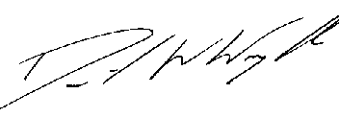
Clerk: D W Wright
The Garth
2 Broc Hill Way
Milford
Stafford, ST17 0UB
Tel: 01785 661182
11th October 2023 actontrussell.clerk@yahoo.co.uk

Websites!!!! www.actontrussell-pc.co.uk and www.batth.co.uk

