
NOTICE OF MEETING

ACTON TRUSSELL, BEDNALL & TEDDESLEY HAY PARISH COUNCIL

Annual Parish Assembly
Wednesday 11th May 2022 – 8.00pm
at Acton Trussell Community Centre

AGENDA

- Apologies
- Chairman's Report
- Minutes of last Parish Meeting 19th May 2021
- Finance
- District Councillors Report
- County Councillors Report
- Community Centre report
- Discussions:
Village Issues

This meeting will be followed by the ANNUAL PARISH COUNCIL MEETING

This is a PUBLIC meeting and you are invited to attend.
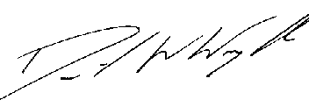
Clerk: D W Wright
The Garth
2 Broc Hill Way
Milford
Stafford, ST17 0UB
Tel: 01785 661182
5thh May 2022
actontrussell.clerk@yahoo.co.uk

Websites!!!! www.actontrussell-pc.co.uk and www.batth.co.uk

