
NOTICE OF MEETING

ACTON TRUSSELL, BEDNALL & TEDDESLEY HAY PARISH COUNCIL
Parish Council Meeting
Wednesday 18th September 2024 – 8.00pm
In the Parish Community Centre -Acton Hill Road

AGENDA

Public Question Time. Reports on Local Community Activities

- To receive and consider any apologies for absence

- To receive any Declarations of Interest

- Minutes: To approve the minutes of the meeting of 17th July 2024 and to consider matters arising

- County Councillors Report

- District Councillor’s Report

- Parish Plan – Action list review including

a ) Community Activities & Cohesion – Community Centre & Recreation Field
b) Communication -- Websites
c) Environment - BKV
d) Highways & transport

- Finance
- Bednall Car Park purchase
- Legal Advice
- Consultants on Planning
- To review Audit Report
- To receive a report on the Accounts for the year to date
- To approve accounts for payment

- Planning
- To report on Planning decisions
- To discuss current Planning Applications and confirm responses.

- To receive and consider items of correspondence

- Reports from Councillors

- Risks

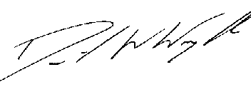

Clerk: D W Wright
15 Brindley Bank Road
Rugeley
WS15 2EY
Tel: 01889 441049
10/09/ 2024 actontrussell.clerk@yahoo.co.uk

Websites!!!! www.actontrussell-pc.co.uk and www.batth.co.uk

